**Lakshya Society for Public Health Education & Research**

**Activity Report**

**Year 2022**

1. As we all know that India has highest burden of TB in the world. Undernutrition in the Indian context increase the risk of TB disease among those who have latent TB infection. Undernutrition at the population level contributes to an estimated 55% of annual TB incidence in India. In countries like India, where undernutrition is a common and potentially serious comorbidity in TB patients, nutritional support would be a significant step forward in implementing patient-centred care as well addressing comorbidities of patients with TB. In this direction Lakshya board members came together and adopted few TB patients from a TB clinic in Pune and pledge to provide nutrition to them until their TB treatment is completed. Lakshya is also planning to register under government’s Nikshya Program to contribute in providing nutrition to TB patients.
2. Smita Nimkar one of our board member also arranged world AIDS day program in BJ Medical College at ART canter.

People Living HIV (PLHIV) expressed their thoughts gratefulness towards the research that made their life less complicated and bearable. A street play was presented based on this year’s theme - Equalize, projecting the fact that people are treated differently in different layers of society.

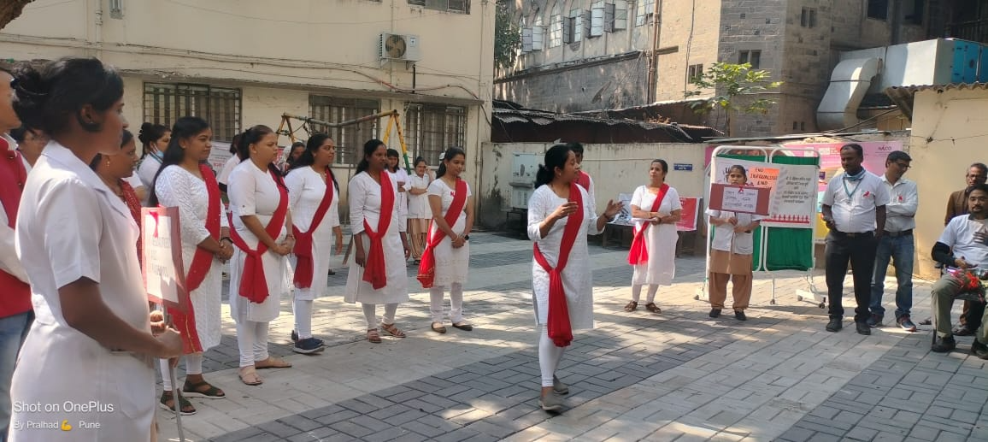

1. Dr. Nishi Suryavanshi conducted a training in YASHDA for Clinicians working in government hospitals. Following topics were covered.

Why Ethical Guidelines/norms are important?

Why documentation is important in research?

What are investigator’s responsibilities

What are sponsors responsibilities?

Why Ethics Committees are formed and what are their responsibilities

What is quality control management plan?

What are ICMR guidelines?

