1. **Activity Reports:-**
2. **ACTIVITIES IN YEAR 2012**

Although Lakshya is registered in July 2010 our activities started in Feb 2011. At present Lakshya has given contracts to 20 highly experienced and qualified individuals like: Regulatory coordinator, lab manager, community coordinators, counselors, data management team etc…. to conduct following activities.

1. **HIV Counseling and testing facilities**: In 2012 almost 3600 pregnant mothers were given information on

* What is HIV?
* What is difference between HIV and AIDS.
* Mode of transmission of HIV
* Need for doing HIV test in pregnancy.
* Information on importance of nutrition, regular clinic visits, taking regular medicines during pregnancy.
* Information on availability of medicines to prevent HIV transmission to unborn baby if HIV test is positive.
* Rapid HIV tests were done on women who consented and results were made available to them within 20 mins of test administration.

All HIV infected pregnant women were provided with post test counselling on the following and HIV negative women were given additional general prevention counselling and were encouraged to undergo a repeat testing after 3 months.

* Report disclosure
* reinforce family planning, use of condom
* risk reduction measures
* need based referral
* diet, mother to infant HIV transmission, infant feeding counseling
* other infections associated with HIV
* Provide psycho social support to the patient.
* Spouse notification.

1. **Development Of Patient education Material**

Ultimately, the only way to significantly reduce the risk mother-to-child transmission of HIV is to prevent women becoming infected. This can be effectively achieved through education, empowerment and promotion of HIV prevention tools such as use of condoms. All women have a right to HIV testing and counseling, but this is especially true for pregnant women and new mothers. This facility was provided by Lakshya to mothers who belong to low socio- economic strata.

We also developed Patient education material for infant feeding counseling A research study, in collaboration with experts from all over the world, was conceptualized to reduce the risk of HIV transmission from mother to child. This research study protocol was developed keeping in mind that pregnant women from India would be maximally benefited. This protocol was approved by the Indian Council of Medical Research (ICMR). This study is called PROMISE and Lakshya implemented this protocol in collaboration with BJ Medical College & Sassoon General Hospitals, Pune.

In India breast feeding is the cultural standard of care for infant nutrition and care. Although, HIV may be transmitted through breast feeding, there are various factors that make HIV infected women to choose breast feeding as an infant feeding option. Possible reasons include some of them have not disclosed report to their family members, cannot afford powdered milk, have no access to safe drinking water, have problem in making fresh milk every time baby is hungry and have problems in feeding baby during night time.

We have developed education material on infant feeding and counsel women how they can exclusively breast feed their babies and reduce transmission of HIV transmission.

1. **Trainings and Meetings:**

* **Sessions conducted with Community Advisory Board (CAB):** CAB members were trained on PROMISE Study so that they can go back and sensitize their community workers about medicines available to pregnant women through PROMISE study.
* The PROMISE Study has been designed to look for the best way to prevent the transmission of HIV from a mother to her baby during **pregnancy** and **labor and delivery** and the best way to prevent HIV transmission during **breastfeeding.**
* Training session were conducted with study staff ..
* Meetings were conducted in Pimpri Chinchwad Municipal Corporation Hospitals and Pune Municipal Corporation Hospitals to give information about PROMISE study and referral of HIV positive pregnant women who could get benefit from the study.

6-7 video conference case discussions happened every month to equip doctors with skills and knowledge on HIV and TB treatments and Hepatitis B updates.

1. **HIV Disclosure study:** Currently there are no guidelines in India that can help HIV positive parents to disclose HIV **status to their child**ren. HIV positive children are inquisitive about their illness. They wonder why they need to take medicines everyday and for how long they have to take these medicines?

Resource poor settings, such as ours, often suffer from multiple challenges such as overburdened staff, space and time constraints and limited privacy. Moreover, caregivers, who may be HIV positive themselves, are often unable to handle adequately various clinical, psychological, social and behavioral demands on themselves or their children.

* + 1. Preparatory work for HIV disclosure study started in March that involved developing interview guides, informed consent forms and their translation into Marathi so that local population can understand purpose of the study, participants rights and procedures involved in the study.
    2. Talk about details in outreach activities.
    3. Discuss that HIV infected patients are given contact information of doctors and counselors so that can contact them 24/7 for any medical or social emergency.

1. **ACTIVITIES IN YEAR 2013**

Lakshya also conducted a workshop for empowerment of HIV positive women.

This workshop was a residential workshop where 12 women participated and were given extensive life skill, capacity building training. Data collection tools and workshop material were developed by Lakshya staff.

Workshop was conducted at Sai baba seva trust at Kanhe. Although 15 participants agreed to participate only 11 participants turned up and 9 completed the training.

The workshop focused on various aspects of life such as relationships, body, Sexuality, Money, Work, and Emotions. Workshop started with small group exercises, group discussion, body mapping and psychological therapies and ended with deriving personal goal for herself and ways to achieve it.

These activities helped women to express their problems, concerns, emotions which otherwise are “silent”. This three days residential workshop gave them the opportunity to be away from their routine work and just to think about them, open up share their problems with many women like them. There were many light moments that made participants happy, relax, laugh, spend some time with oneself, and make new friends among the group. These women have shown 100% retention, not missed any study visit and develop confidence. A study was written in collaboration with John Hopkins university between May 2011 and Dec 2012.

Preparation for an implementation science study.

Under the current DAC PMTCT guidelines, there are already challenges to the adherence to HIV services, Option B+ will require even longer periods of adherence. Therefore it is important to identify implementation strategies to optimize the public health impact of the new PMTCT guidelines. The central hypothesis is that the intervention proposed will result in optimized program implementation for each of the four key PMTCT components. Hence this study in collaboration with MSACS, will address key barriers to the uptake of the new DAC PMTCT components.

Through the optimized implementation of the four PMTCT components, we expect to see enhanced uptake and adherence to the four key components of the Option B+ PMTCT program by HIV+ pregnant and breastfeeding mothers and improved health outcomes for both the mothers and babies. The study will test the impacts of intervention in an effort to optimize implementation of the national PMTCT program. Our partnership with MSACS ensures that the design of our intervention and the results of this study will be locally relevant and inform the national program. This study was submitted for funding to CDC, Atlanta, US.

India has the world’s largest burden of TB (26% of the global burden), with 2 million new cases/year and estimated to have second largest MDR-TB burden (3,9,10).Approximately 4500 TB suspects (6-700 (15%) HIV +ve) are evaluated annually at our site . Various activities are conducted to run TB studies smoothly starting training of staff to procure uninterappeteed supply of diagnostic kits for TB. BJMC has established a new microbiology TB laboratory (BSL-2) and have obtained certification to conduct TB smear, culture and species identification.

Lakshya provides statistical assistance to Johns Hopkins scientist for analysis for NWCS319 data that were generated from the parent ACTG study. The ACTG study, A 5175 was conducted in 9 countries, with NARI and YRG Care, participating from India. The NWCS319 is the case-cohort study that examines the effects of micronutrient, inflammation and activation biomarkers on HIV disease progression measured as clinical, virological and immunological failures. Lakshya only assists in biostatistics and manuscript writing services since 2012.

1. **ACTIVITIES IN YEAR 2014**

In the context of the PMTCT study, Lakshya is focusing the specific intervention efforts on two primary players in the care continuum, 1) the Out Reach Worker (ORWs) and 2) the HIV+ pregnant or breastfeeding women. It is understood that there are many other forces (structures and people) that will ultimately influence care patterns; however, this intervention is focused on the ORW-client dyad as a focal point for positive behaviour change.

We are currently developing training material for ORWS in intervention arm on following components:

* On scientific basis for PMTCT guidelines to fill in knowledge gap.
* Active learning techniques will be used to increase knowledge acquisition among ORWs.
* Focus on counselling strategies and personal engagement techniques.
* Training on interviewing techniques such as motivational interviewing (MI) to engage with their patients and enhance patient’s positive attitudes and subjective support towards the positive behaviour change.
* emocha training including operation of the device, -security features, video demonstration

The ORWs from the intervention arm will be asked to carry out their activities with the help of Samsung tab 3. The devices will be equipped with four educational videos in the local language explaining the importance of each of the four key PMTCT components.

1. ART initiation and adherence by pregnant and breastfeeding women

2. Daily Infant prophylaxis initiation and adherence

3. Exclusive breastfeeding for first 6 months.

4. Early Infant Diagnosis.

Story telling videos are developed with full frame productions. Script was written by Lakshya staff in local language Marathi and finalised after due discussions with other collaborators. These videos will display an interactive learning session between an ORW and pregnant women from HIV screening to breastfeeding and HIV testing of infants. These videos will be displayed to patients on ORW visits as and when required. These will help ORWs to interact with patient and counsel them in more efficient way actually showing them how each of PMTCT component help.

* Study related case report forms, standard operating procedures, manual of operations for the study are developed and pretested from March 2014 until Sept 2014.
* Study related informed consent forms are developed in English and translated into Marathi.
* Lakshya Ethics Committee meeting held on 27 May 2014 where this study was presented in details and approved by EC.

1. **Activities from 2015**

Preparation for an implementation science study.

Under the current DAC PMTCT guidelines, there are already challenges to the adherence to HIV services, Option B+ will require even longer periods of adherence. Therefore, it is important to identify implementation strategies to optimize the public health impact of the new PMTCT guidelines. The central hypothesis is that the intervention proposed will result in optimized program implementation for each of the four key PMTCT components. Hence this study in collaboration with MSACS, will address key barriers to the uptake of the new DAC PMTCT components.

Through the optimized implementation of the four PMTCT components, we expect to see enhanced uptake and adherence to the four key components of the PMTCT program by HIV+ pregnant and breastfeeding mothers and improved health outcomes for both the mothers and babies. The study will test the impacts of intervention in an effort to optimize implementation of the national PMTCT program. Our partnership with Maharashtra MSACS ensures that the design of our intervention and the results of this study will be locally relevant and inform the national program.

In the context of this study, we are focusing the specific intervention efforts on two primary players in the care continuum, 1) the ORW and 2) the HIV+ pregnant or breastfeeding women. It is understood that there are many other forces (structures and people) that will ultimately influence care patterns; however, this intervention is focused on the ORW-client dyad as a focal point for positive behaviour change.

We are currently developing training material for ORWS in intervention arm on following components:

* On scientific basis for PMTCT guidelines to fill in knowledge gap. This training
* Active learning techniques will be used to increase knowledge acquisition among ORWs.
* Focus on counselling strategies and personal engagement techniques.
* Training on interviewing techniques such as motivational interviewing (MI) to engage with their patients and enhance patient’s positive attitudes and subjective support towards the positive behaviour change.
* emocha training including operation of the device, -security features, video demonstration

The ORWs from the intervention arm will be asked to carry out their activities with the help of Samsung tab 3. The devices will be equipped with four educational videos in the local language explaining the importance of each of the four key PMTCT components.

1. ART initiation and adherence by pregnant and breastfeeding women

2. Daily Infant prophylaxis initiation and adherence

3. Exclusive breastfeeding for first 6 months.

4. Early Infant Diagnosis.

Story telling videos are developed with full frame productions. Script was written by Lakshya staff in local language Marathi and finalised after due discussions with other collaborators. These videos will display an interactive learning session between an ORW and a pregnant woman from HIV screening to breastfeeding and HIV testing of infants. These videos will be displayed to patients on ORW visits as and when required. These will help ORWs to interact with patient and counsel them in more efficient way actually showing them how each of PMTCT component help.

* Study related case report forms, standard operating procedures, manual of operations for the study are developed and pretested from March 2014 till Sept, 2014.
* Study related informed consent forms are developed in English and translated into Marathi.
* Lakshya Ethics Committee meeting held in December, where this study was presented in details and approved by EC.

1. **Activities from 2016**

We have arranged training for 60 outreach workers who are employed by Maharashtra State AIDS Control Society to link HIV infected pregnant women to care and follow them up until baby becomes 18 months of age to prevent mother to child transmission (PMTCT) of HIV. Under the current national PMTCT guidelines, there are already challenges to the adherence to HIV services, new PMTCT guideline implementation will require even longer periods of adherence. Therefore, it is important to identify implementation strategies to optimize the public health impact of the new PMTCT guidelines. Hence in collaboration with MSACS, we tried to address key barriers to the uptake of the new PMTCT guideline.

From 2015 to 2016 extensive training was conducted for outreach workers by Lakshya staff at four high HIV burden districts of Maharashtra. This training was to provide outreach workers with appropriate information and knowledge on HIV transmission from mother to child, why ART initiation is important for mothers, why baby should be immediately started on anti-HIV prophylaxis, why mothers should exclusively breastfeed their babies, how stigma to HIV, challenges to access health care services can be overcome, is provided in Marathi language. ORWs will also be given training on how to use tablets to collect data from HIV infected women about their medicines, child’s HIV testing and their Anti - HIV medicines and infant feeding. Outreach workers were also given empowerment training with yoga and meditation and motivational counseling technique so that they can appropriately engage with their patients.

Lakshya also prepared four videos in local language to help ORWs to counsel HIV infected pregnant and delivered women to understand the importance of starting and continuing anti -HIV medicines, breastfeeding, baby’s HIV testing and starting baby on anti-HIV prophylaxis.



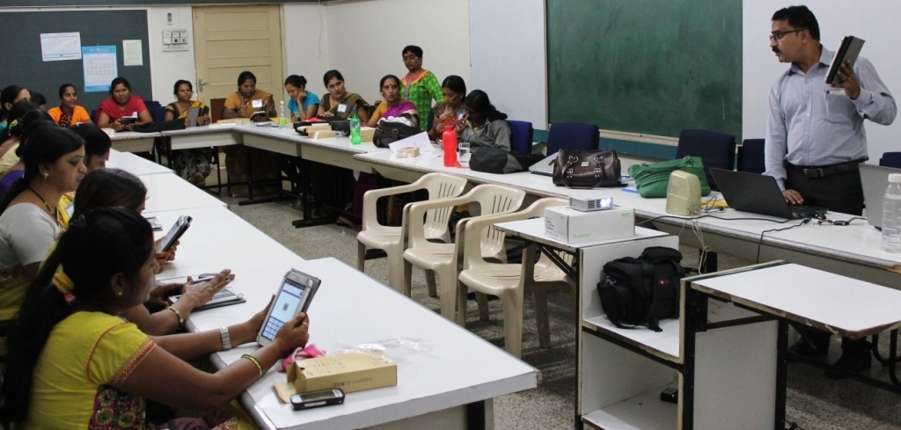

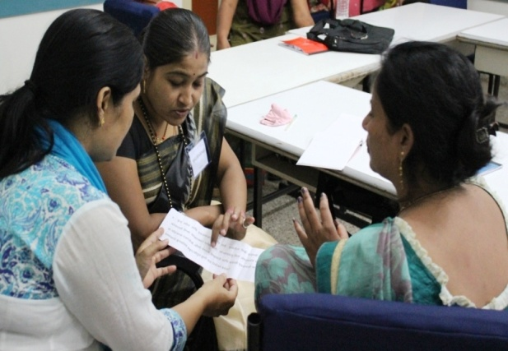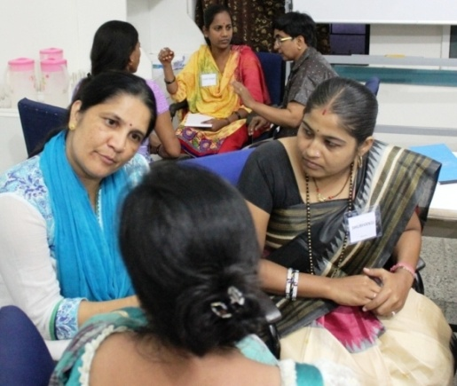



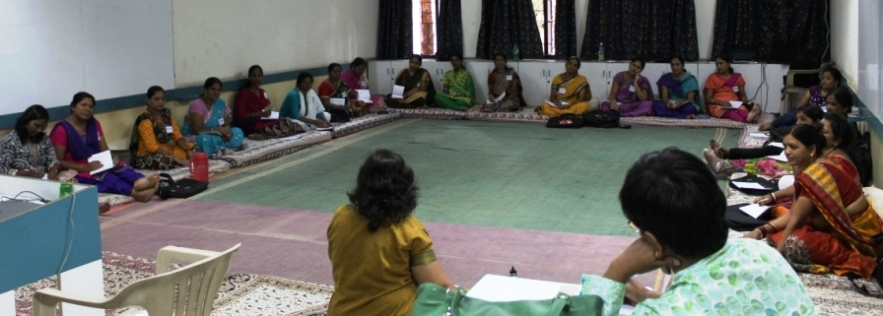

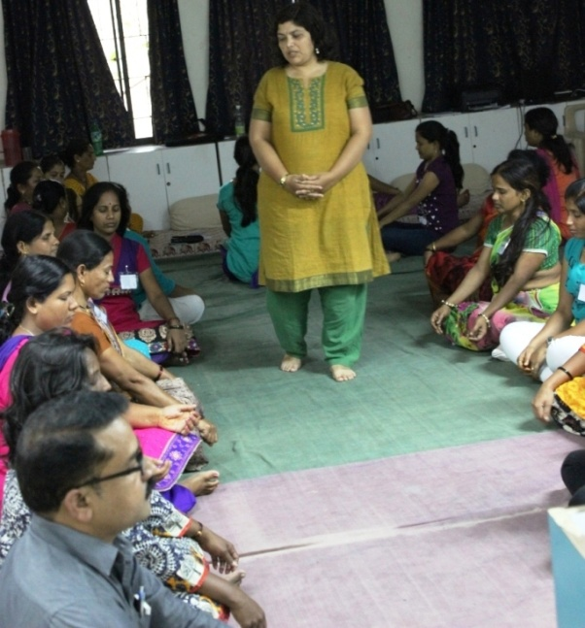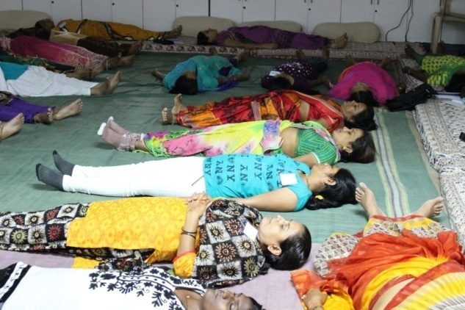

**Group activities: Realizing “self” Yoga and meditation**

1. **Activities from 2017**

* Lakshya field workers approached **1200+ HIV infected** pregnant women in four districts of Maharashtra namely, **Sangli, Satara, Pune and Thane** and provided counseling on prevention of mother to child transmission of HIV and linked them to care. These activities were conducted after approval from National AIDS control organization of government of India and Maharashtra. Social scientists also conducted in-depth interviews with outreach workers and HIV infected women to understand what challenges they face in accessing HIV care in government hospitals. They also conducted interviews to find out if the training conducted by Lakshya had an impact on increasing knowledge about HIV and hence if there is increase in proportion of women initiating anti-HIV medicines, increase in proportion of women opting for exclusive breastfeeding and HIV testing for babies for 18 months.
* Educational activity workshop for HIV infected women was held on Saturday, 27th August 2016.
* 35 female participants and 15 staff members participated in the workshop. The purpose of the workshop was to appreciate these participants keeping adherent to study visits and drugs and maintaining good retention. Their valuable contribution will help in advancement of science and HIV drugs. The purpose was also to empower these women with key messages related to HIV infection, drug adherence, TB, nutrition and parenting so that they can adopt the information in their daily life and change oneself for betterment of their own health and their children’s health as well.
* The workshop started with session on HIV /AIDS and Tuberculosis (TB). Dr. Sandesh Patil, MBBS, DGO, Gynecologist who conducted an interactive session by using audio-visual aids, on difference between HIV and AIDS, modes of HIV transmission, HIV testing, PPTCT program, Ante-retro viral Therapy (ART) and ART adherence.

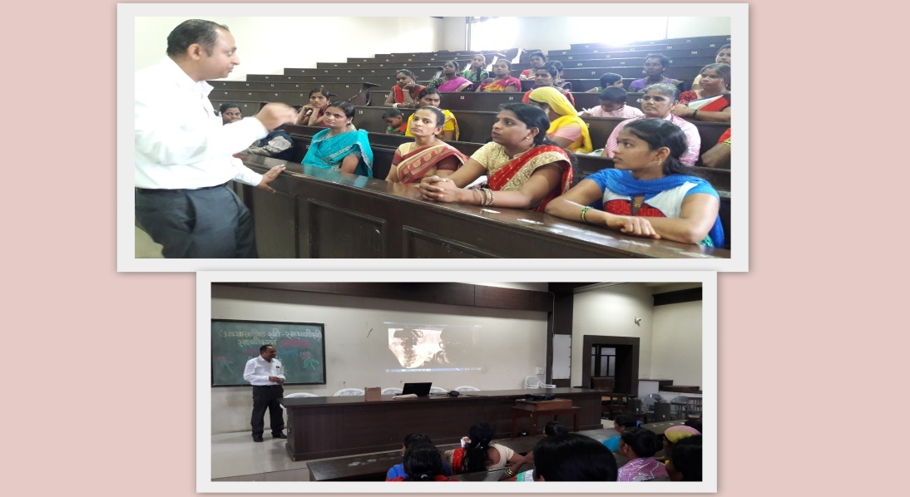

* About TB, he talked on TB screening, different types of TB, Directly Observed Therapy (DOT) and its importance and role of Revised National Tuberculosis Control Program (RNTCP).
* The session was reconsideration for participants as they had received all these information through counseling during their study visits.
* Dr. Medha Kulkarni, MD, Ph.D, and Prof and Head at Dr. D. Y. Patil College at Ayurved and Research Centre, Pune, guided participants on nutrition for themselves and their children.

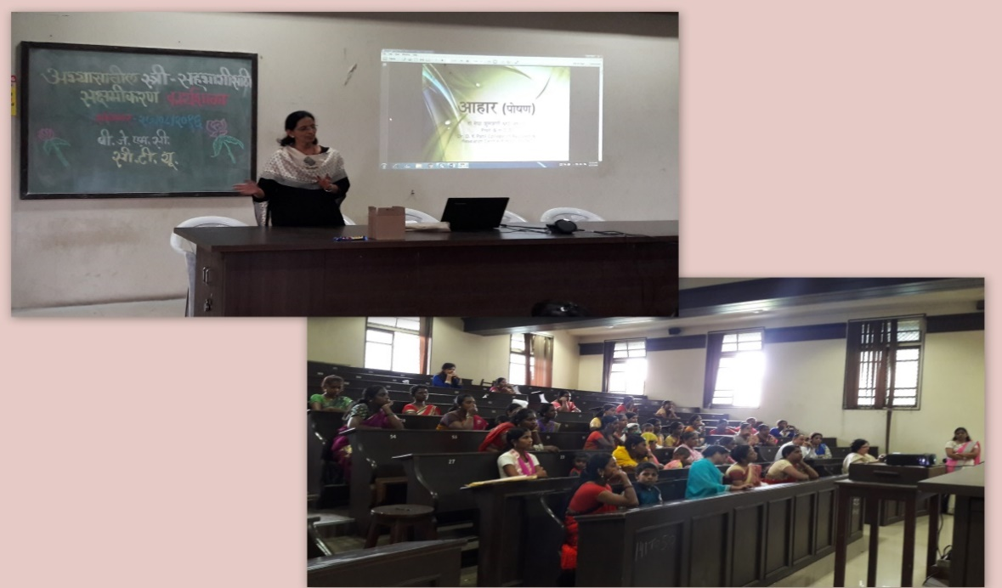

* She covered topics like functions of nutrition, different characteristics of food, cooking methods, proportion of food items, what to eat when immunity is poor etc. She also described some healthy recipes for participants themselves and their children. Participants liked the session because it was given in very simple language and described recipes that are made with locally and easily available food items.
* Session on Parenting was taken by Dr. Ujjwal Nene, Consultant Psychologist at K. E. M. Hospital.

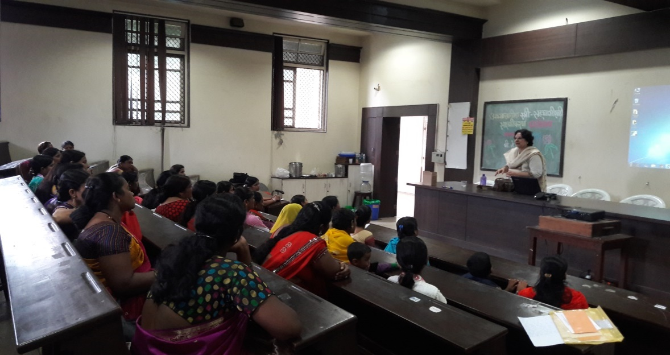

* She described various stages of child development and abnormalities related with their development. She also talked on role of parent in child’s growth, taking their home-work- studies, disciplining the child, handling stubborn child, behavior problems, watching TV, playing with mobile etc.
* Many participants shared their personal experiences and asked questions related to behavior problems.
* Post lunch session was focusing on topics on empowerment. Ms. Savita Kanade, MSc (Anthropology) and working as Community Coordinator at BJMC CRS carried out the session. The Short video film was shown on troubles or problems or sufferings. The discussion was occurred on how they play important role in our life and what should be our outlook towards resolving them and how important to bring change for sustaining in life.
* A session on guided visualization was taken. The purpose of the activity was making participants rethink on what they went through in their life and identifies what went wrong and what work out very well.

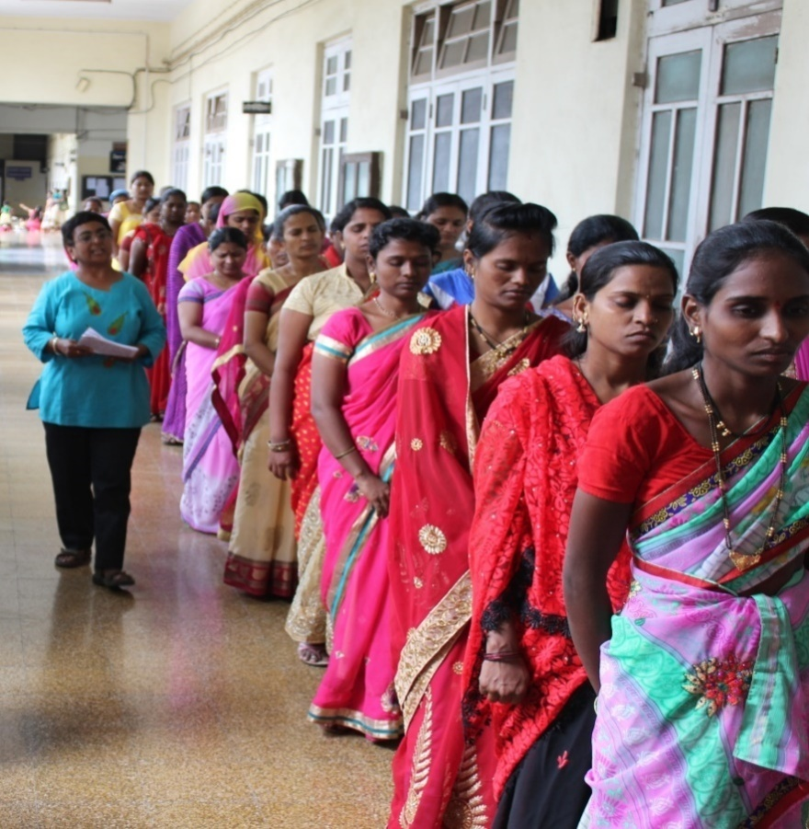

* The activity helps participants to have emotional burn out and helps in sharing their experiences which they never shared with anybody.
* When sessions were going on for women, our staff carried out drawing activity for children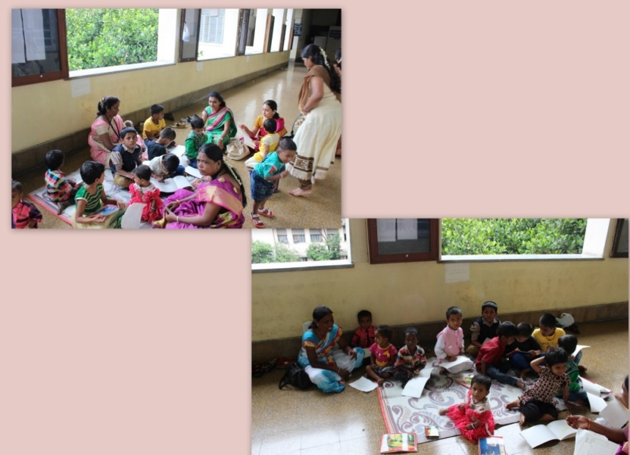
* Beside these activities,
* Three update meeting were conducted with MSACS.
* Every month meeting with district program me officers were attended by Lakshya staff to discuss the challenges face d by patients and ORWs and how they can help overcome those.
* Lakshya has also arranged training for all staff and ethics committee members on ICMR bioethical guidelines and human subject protection requirements while conducting research with humans.
* Statistical assistance is provided by Dr. Nikhil Gupte to various scientists and students at BJ medical college and Pune University.

Nishi Suryavanshi mentored two students from Pune university for 6 weeks on research methodology, quality control and quality assurance of research data, how to develop data collection tools and qualitative research methods. These students were also given exposure to work with community and observed how our outreach workers and staff interact with patients in community keeping confidentiality of their HIV status.