Lakshya has conducted various activities in 2018 for household contact of TB patients and women living with HIV. These activities helped women to express their problems, concerns, emotions which otherwise are “silent”. This workshop gave them the opportunity to be away from their routine work and just to think about themselves, open up share their problems with many women like them. There were many light moments that made participants happy, relax, laugh, spend some time with oneself, make new friends among the group. They were provided information about nutrition and how to tackle mental stess in life. This information was provided by a nutritionist. She also explained simple nutritious recipes that can be prepared from items available at home. One clinical psychologist from BJ Medical college and Sassoon Hospital discussed about mental stress and how to relieve it with simple ticks and diverting attention

We hope that this workshop will bring changes in self-efficacy, decision-making, personal relationships and ability to adapt to their surroundings and result in an increased sense of individual empowerment and quality of life.

In December 2018 AIDs day is celebrated in Sassoon hospital by arranging a street play depicting importance of taking regular ARTs and visits to clinic

In 2019 Lakshya staff also prepared MDR TB video to create awareness about clinical research on MDR TB prophylaxis study for household contact. A video was prepared in Marathi language with English subtitles and was shown to family members of TB patients and hospital staff in TB hospitals in Pune District. Video gave information on MDR TB disease, importance of prevention among household members, importance of regular treatment and adherence, management of side effects of MDR TB drugs, consequences of irregular treatment or if treatment is stopped in between and why it is important to participate in clinical trails that use new MDR TB preventive treatments.

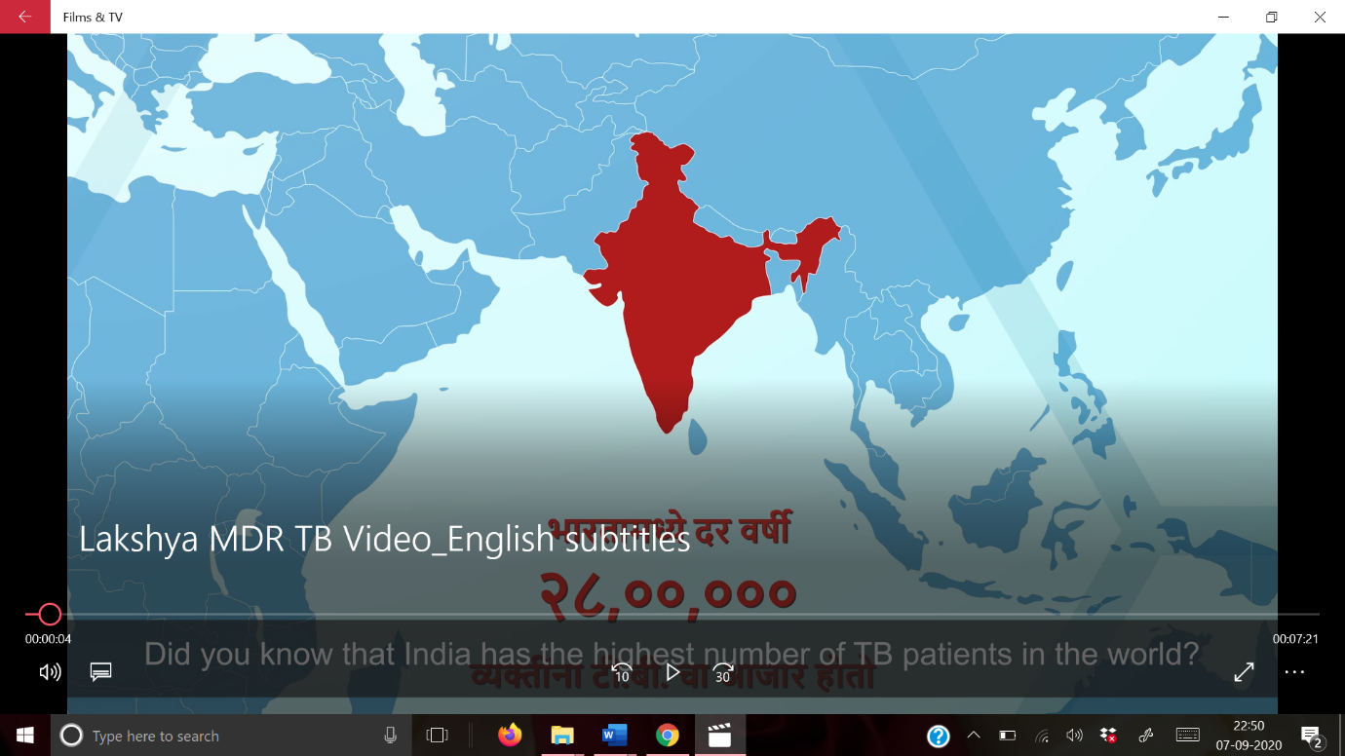

In 2019 June , a training on clinical research data management was conducted for a clinical research organisation PPCE. One full days training was arranged on Basics of childhood vaccination, immunogenicity and risks involved (signs to look out for /investigate further) Vaccine related adverse reaction / reactogenicity/ example from VPM study. Medical safety issues and adverse event reporting Other Data management/QC issues related to Vaccine studies the team should be alert to

At the end of the training Quiz was conducted and feedback form was completed. 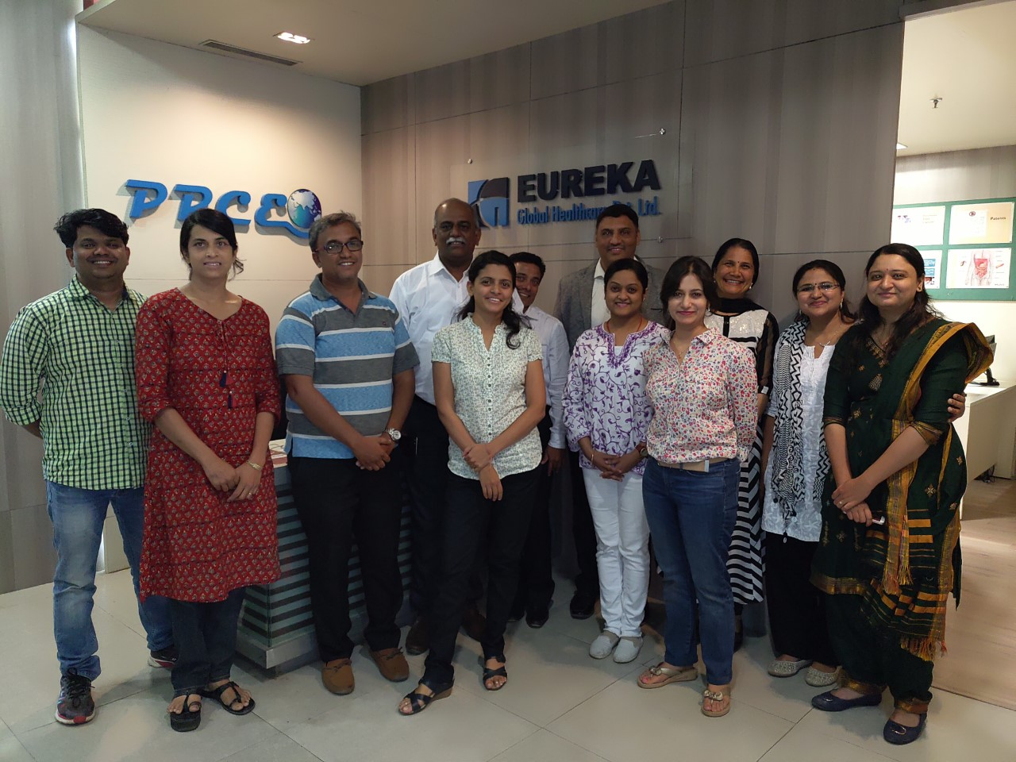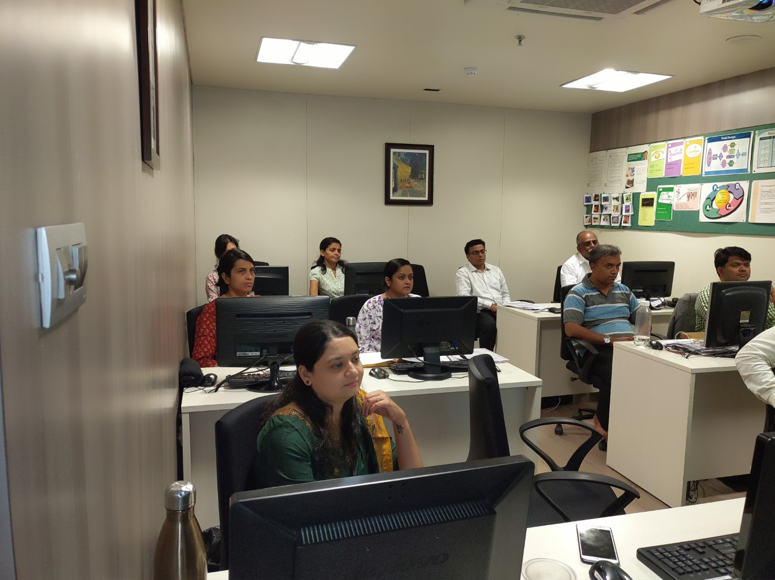In 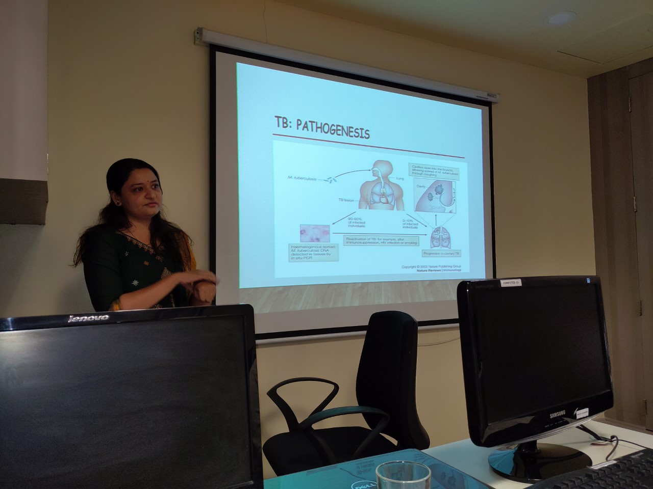

In 2020 Lakshya trustee Dr. Nikhil Gupte has arranged 6 weeks training course in biostatistics in clinical Research. Twenty researchers attended the course from 3rd May to 15th June 2020.

Course is designed, so that:

* You understand the basic concepts of data handling
* You will be able to perform basic analysis
* You & the statistician will be speaking the same language
* You will be able to review & interpret the analysis reports

generated by the statistician

* You will be able to draft statistical sections of your manuscripts
* You will be able read & understand statistical sections in the

manuscripts you review

Lakshya also conducted a study in 2020 on Mental health and quality of life among health care professionals in COVID pandemic and interviewed 210 participants all over India. This study provided important insight into mental health symptoms among health care professionals and how it impacted their quality of life and thus making health care system to devise interventions that can help HCPs to reduce mental stress so that they can work efficiently and cope up with efforts in controlling COVID pandemic. Protecting the mental health of frontline HCPs is paramount to COVID-19 response and control efforts. Rapid development and implementation of interventions to prevent and treat mental health conditions are urgently needed to support the growing number of HCPs caring for COVID-19 patients in India and worldwide. Study is published in Brain and Behaviour in September 2020.

In December 2020

December 10, 2020—Each year, World AIDS Day serves as time for important community outreach.

On Thursday, December 10, an event was organised about awareness and knowledge about HIV and routine care and testing among adolescents living with HIV. Approximately 20 people participated in this awareness program convened in collaboration with BJGMC-JHU CRS TREAT ASIA Team at B J Govt Medical College and Sassoon General Hospitals, Pune.

A group of Adolescents and some of their parents attended the day. The focus was on providing general knowledge about HIV infection, treatment and testing along with balanced diet and positive approach towards life.

counsellors, Mrs Suhasini Surwase, along with other counsellors Mrs. Archana Pawar and Mrs. Kanta Zarekar, and Pralhad Padtiwar gave a presentation on how healthy body and healthy mind leads to happy life. She informed them about importance of regular CD4, Viral load testing and adherence to the ARV medications and why they need to know about it and how this can lead to normal life with viral suppression.

She also emphasized on balanced diet with locally available seasonal fruits, vegetables, grains etc. Similarly, she explained them about the benefit of being positive in the life and how they can lead the life they want.

The program was interactive and many adolescents ask questions about their future life, career guidance, education and courses available. The adolescents got motivated and enthusiastic which resulted into forming a small peer group.

The program ended by distribution of a small basket with snacks, mask and hand sanitiser to these children that was supported by.

